<FORM> IN HTML

LIST IN HTML ->
LIST IS USED TO GROUP DIFFERENT TYPES OF ITEM TOGETHER

DIFFERENT TYPES ARE:-

- UNORDERED LIST
- ORDERED LIST
- DEFINITION LIST: - is similar to word and its explanation in dictionary

->LI :- stand for LIST ITEM
->UL:- stand for UNORDERED LIST
->OL:-> stand for ORDERED LIST

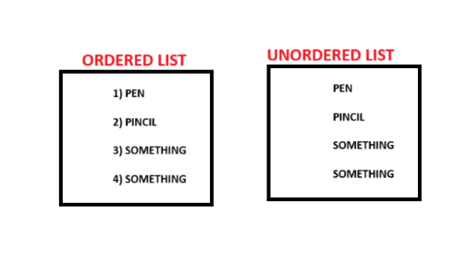

HTML:-
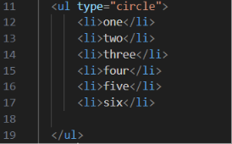
THIS IS EXAMPLE OF UNORDERED LIST IN HTML

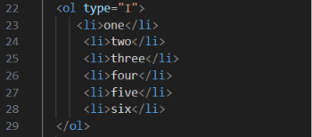
THIS IS ORDERED LIST WHERE TYPE ROMAN

FORM TAGS TOPIC MISSING

GET AND POST METHOD IN HTML

